**BJT Amplifier Characteristics**

**AIM:**

**To verify the frequency response analysis of common emitter amplifier using LTspice software**

**APPARATUS REQUIRED:**

**LTspice software**

**PROCEDURE:**

**Using the components available in LTspice a circuit is built that is used to verify three types of frequency response analysis:**

1. **DC Operating point**
2. **AC analysis**
3. **Transient analysis**

**Command for DC operating point:**

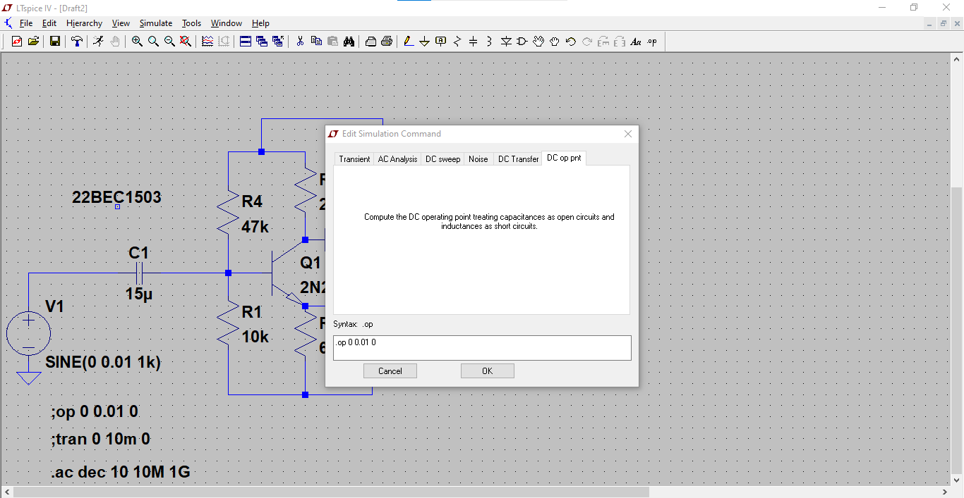

**Command for AC analysis:**

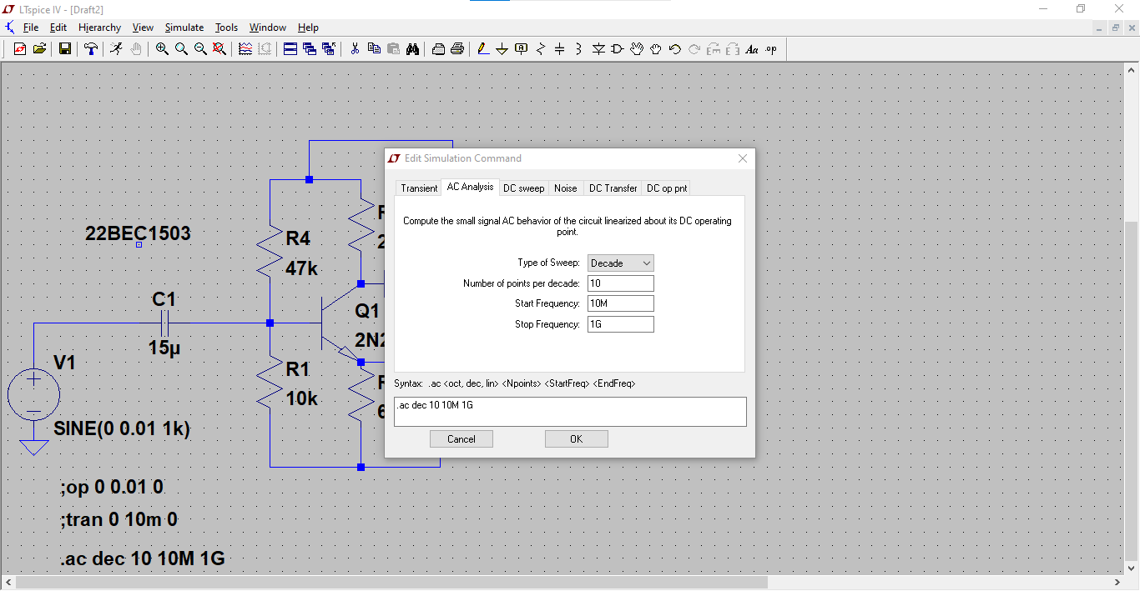

**Command for Transient analysis:**

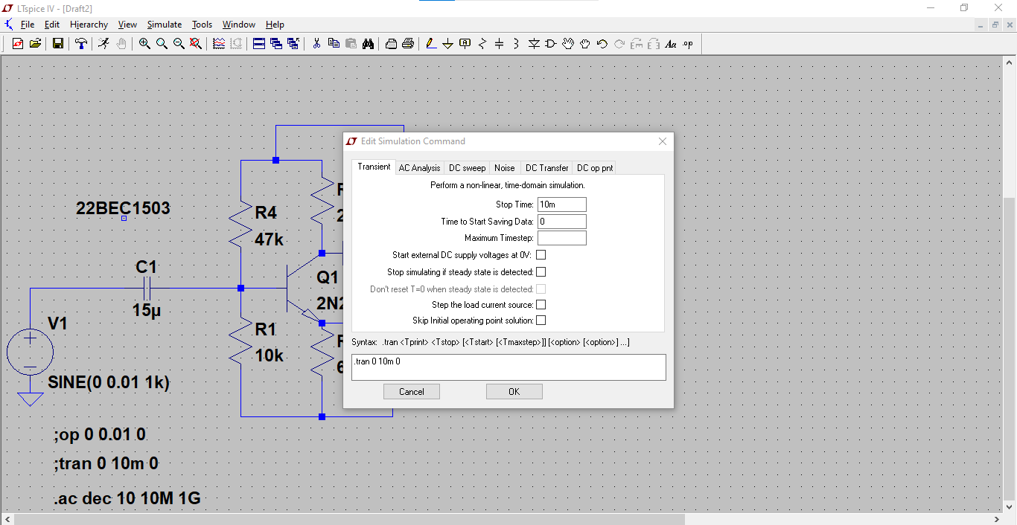

**Circuit and Output:**

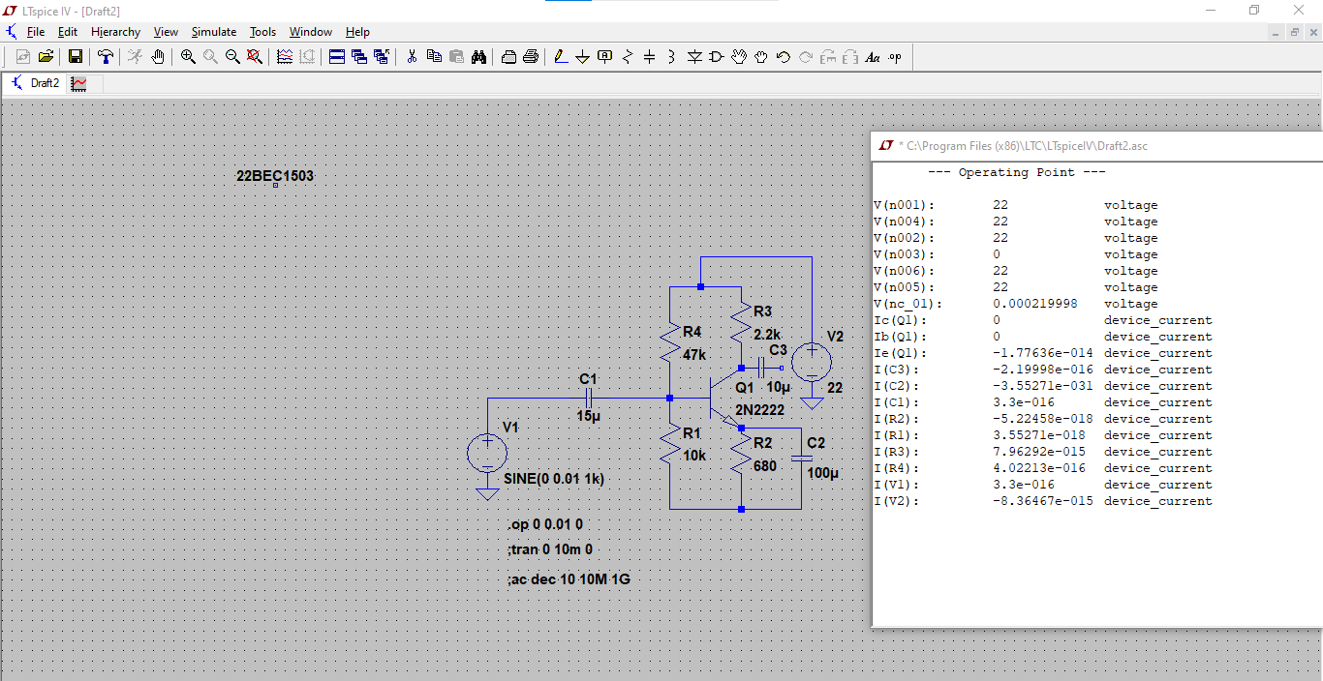

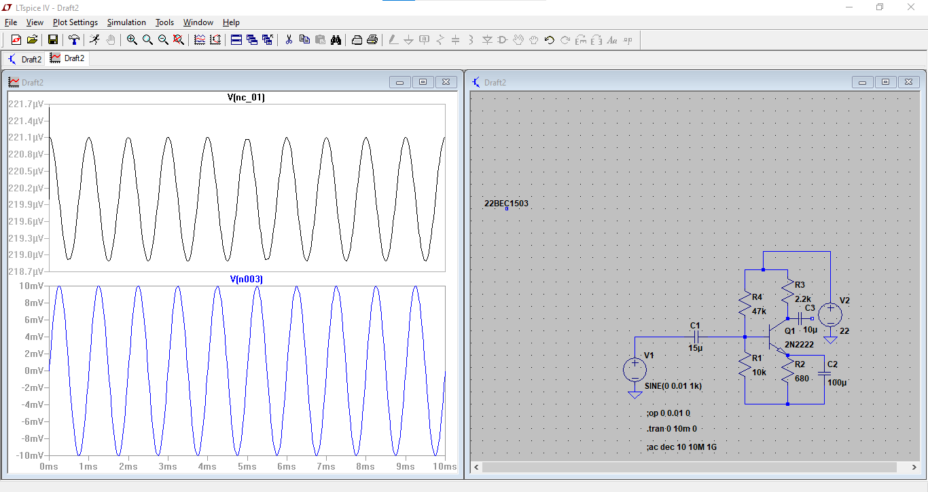

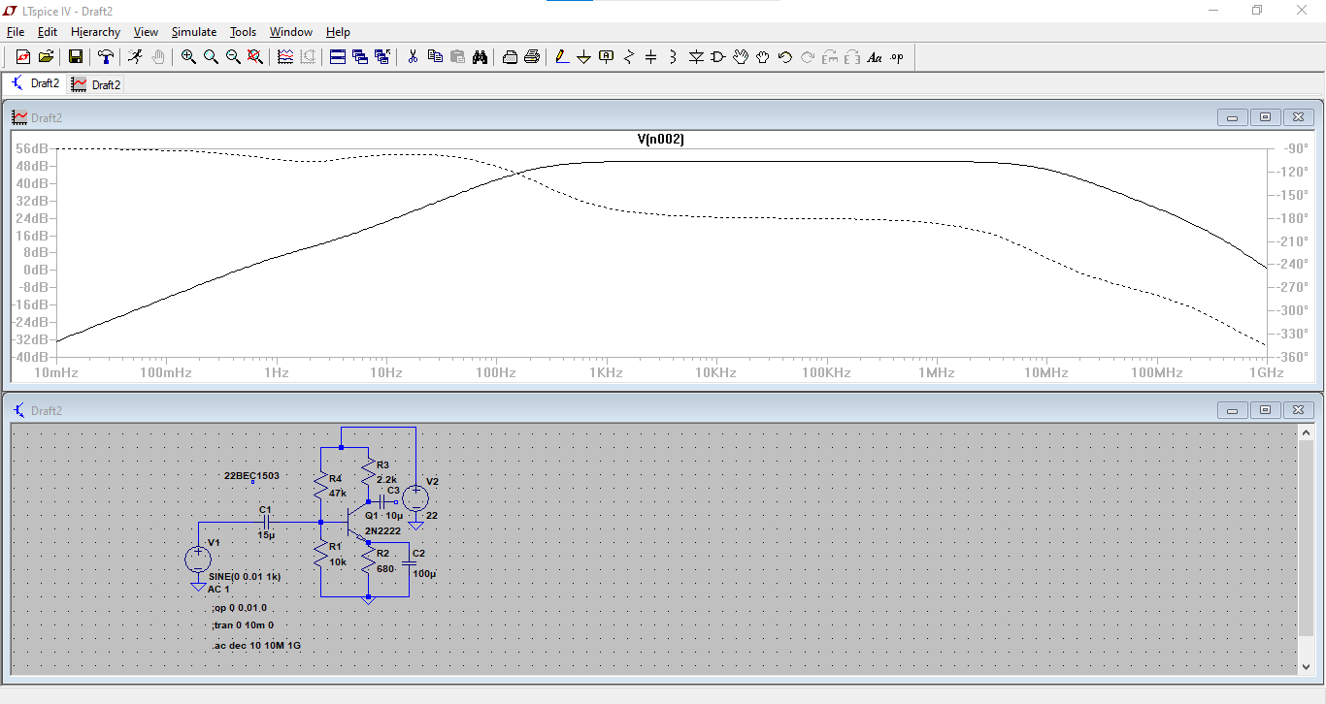

**RESULT:**

**The frequency response analysis of common emitter amplifier using LTspice software is verified.**